Supplementary Material

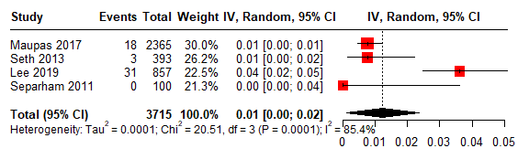
Figure S1. Forest plot of stent thrombosis in studies evaluating Biomatrix stents.
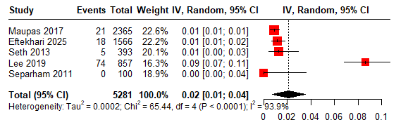
Figure S2. Forest plot of cardiac death (C) in studies evaluating Biomatrix (Bio) stents.
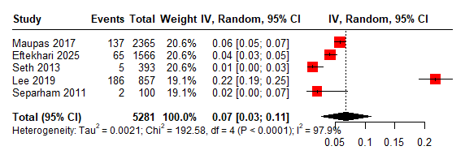
Figure S3. Forest plot of target lesion failure in studies evaluating the Biomatrix drug-eluting stent.
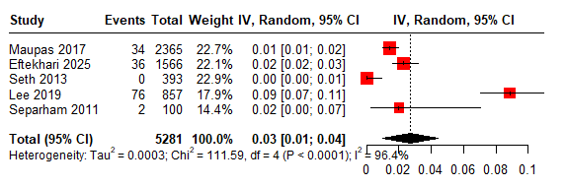
Figure S4. Forest plot of target vessel myocardial infarction in studies evaluating the Biomatrix drug-eluting stent
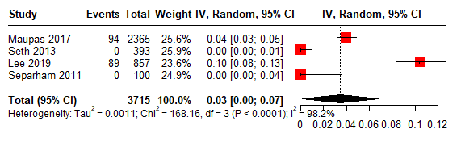
Figure S5. Forest plot of target lesion revascularization in studies evaluating the Biomatrix drug-eluting stent.
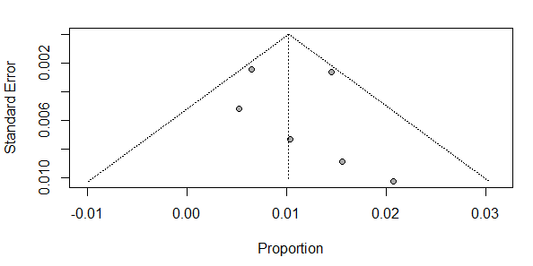
Figure S6. Funnel plot assessing publication bias for all-cause mortality in studies evaluating the Magmaris drug-eluting stent.
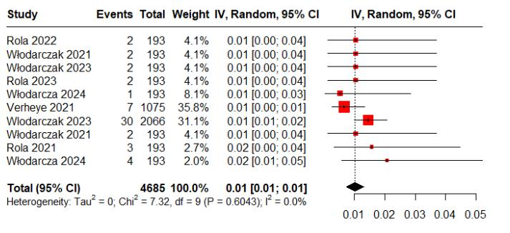
Figure S7. Forest plot of all-cause mortality in studies evaluating the Magmaris drug-eluting stent.

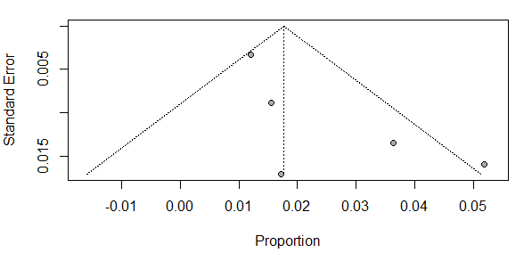
Figure S8. Funnel plot assessing publication bias for myocardial infarction in studies evaluating the Magmaris drug-eluting stent.

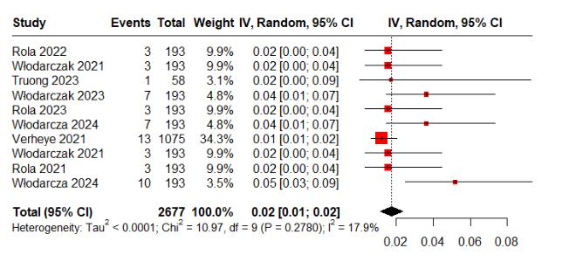
Figure S9. Forest plot of myocardial infarction in studies evaluating the Magmaris drug-eluting stent.

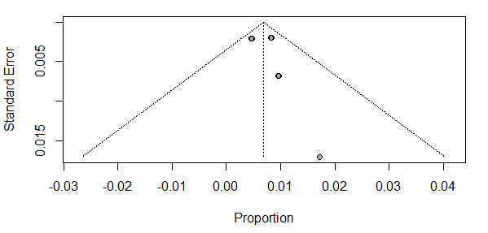
Figure S10. Funnel plot assessing publication bias for stent thrombosis in studies evaluating the Magmaris drug-eluting stent.

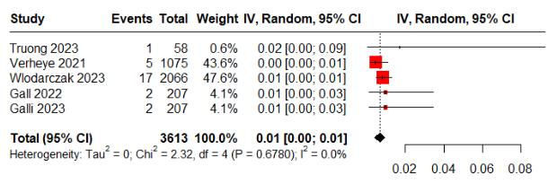
Figure S11. Forest plot of stent thrombosis in studies evaluating the Magmaris drug-eluting stent.
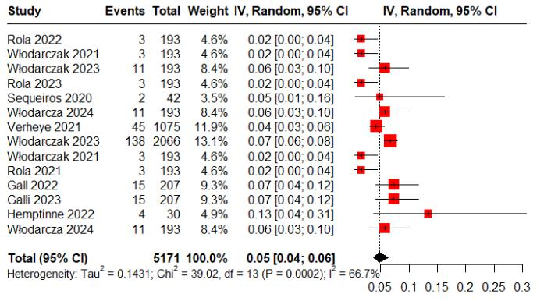
Figure S12. Forest plot of target lesion failure in studies evaluating the Magmaris drug-eluting stent.

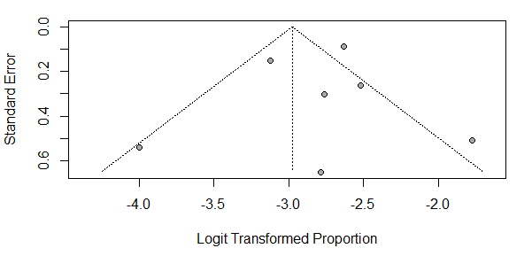
Figure S13. Funnel plot assessing publication bias for target lesion failure in studies evaluating the Magmaris drug-eluting stent.

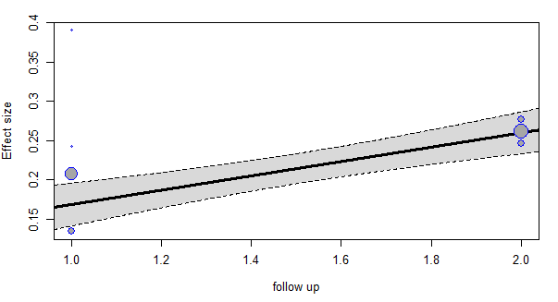Figure S14. Regression analysis of target lesion failure in studies evaluating the Magmaris drug-eluting stent.

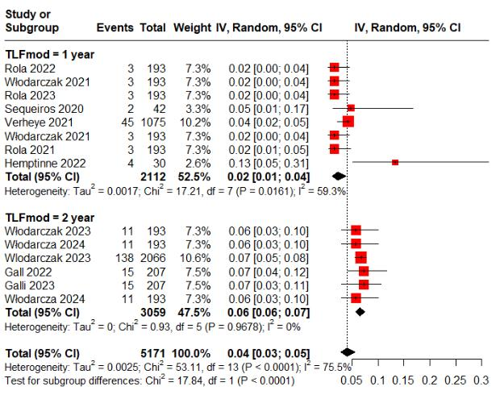

Figure S15. Subgroup analysis of target lesion failure in studies evaluating the Magmaris drug-eluting stent.

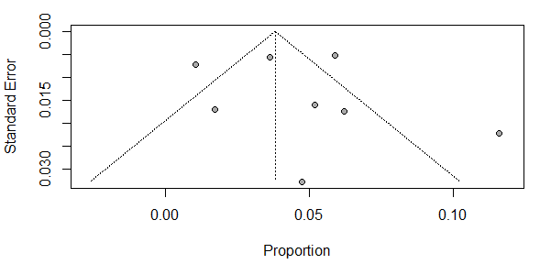
Figure S16. Funnel plot assessing publication bias for target lesion revascularization.

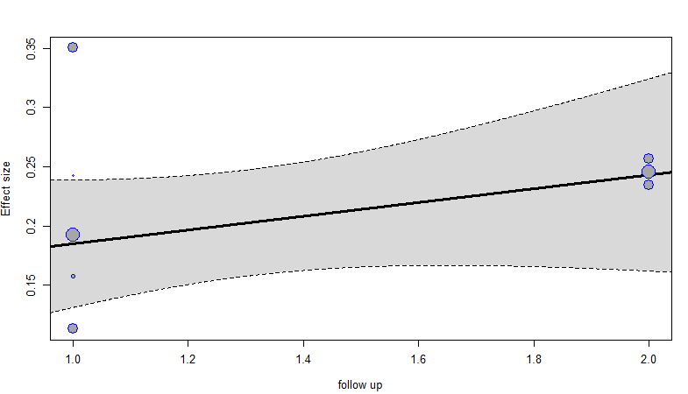

Figure S17. Regression analysis of target lesion revascularization in studies evaluating the Magmaris drug-eluting stent.

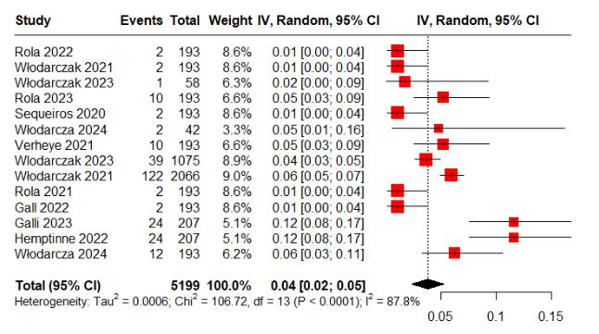

Figure S18. Forest plot of target lesion revascularization for Magmaris.

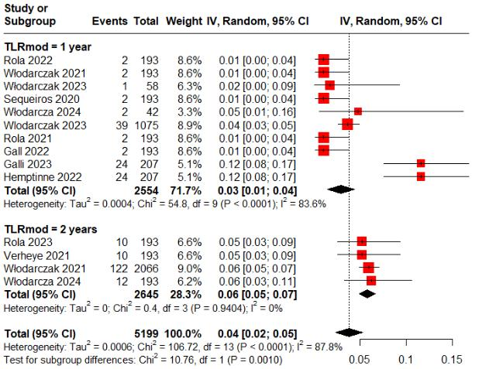
Figure S19. Subgroup analysis of target lesion revascularization

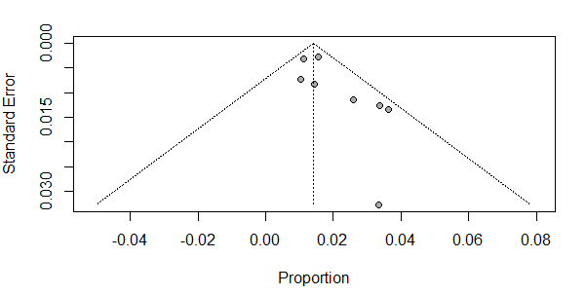
Figure S20. Funnel plot assessing publication bias for target vessel myocardial infarction in studies evaluating the Magmaris drug-eluting stent.

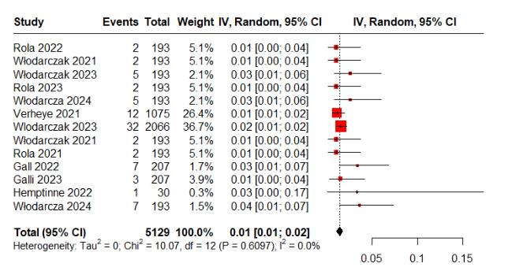
Figure S21. Forest plot of target vessel myocardial infarction in studies evaluating the Magmaris drug-eluting stent.
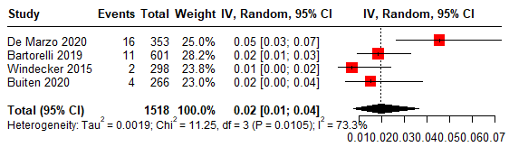
Figure S22. Forest plot of cardiac death in studies evaluating the Orsiro drug-eluting stent.
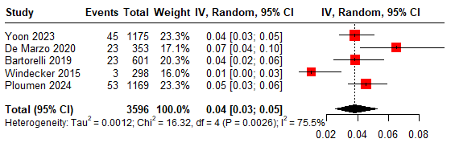
Figure S23. Forest plot of all-cause mortality in studies evaluating the Orsiro drug-eluting stent.
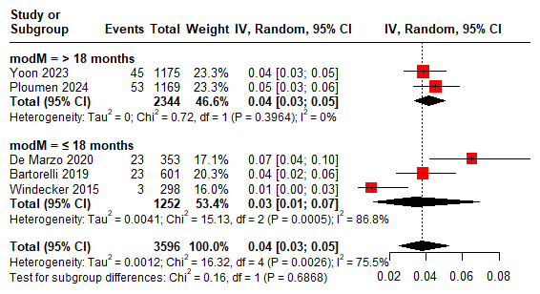
Figure S24. Subgroup analysis of all-cause mortality in studies evaluating the Orsiro drug-eluting stent.
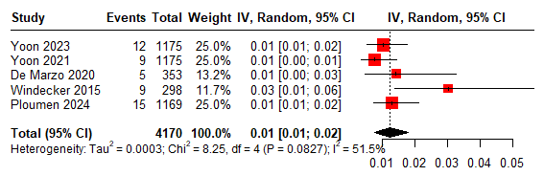
Figure S25. Forest plot of myocardial infarction in studies evaluating the Orsiro drug-eluting stent.
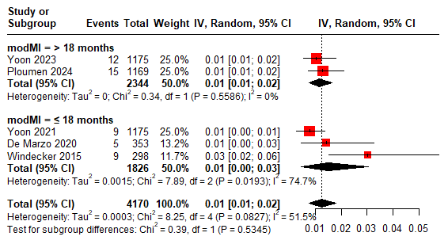
Figure S26. Subgroup analysis of myocardial infarction in studies evaluating the Orsiro drug-eluting stent.
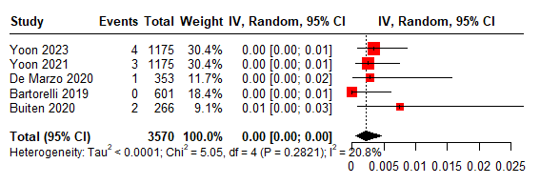
Figure S27. Forest plot of stent thrombosis in studies evaluating the Orsiro drug-eluting stent.

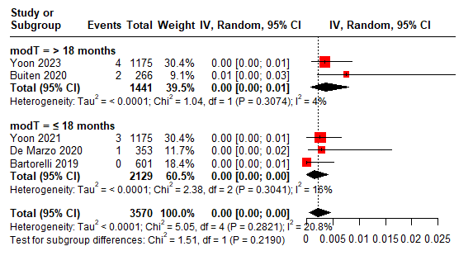Figure S28. Subgroup analysis of stent thrombosis in studies evaluating the Orsiro drug-eluting stent.

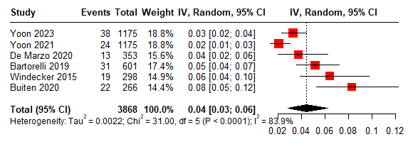
Figure S29. Forest plot of target lesion failure in studies evaluating the Orsiro drug-eluting stent.

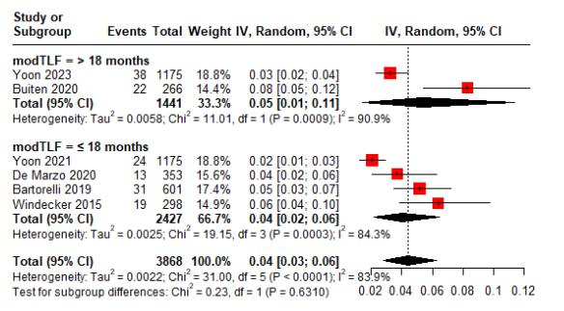
Figure S30. Subgroup analysis of target lesion failure in studies evaluating the Orsiro drug-eluting stent.
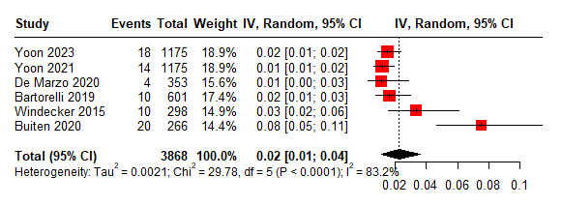
Figure S31. Forest plot of target lesion revascularization in studies evaluating the Orsiro drug-eluting stent.
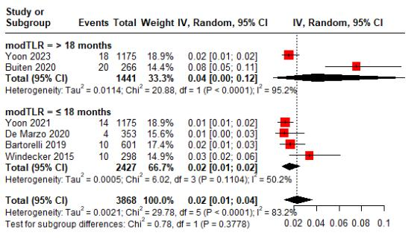

Figure S32. Subgroup analysis of target lesion revascularization in studies evaluating the Orsiro drug-eluting stent.

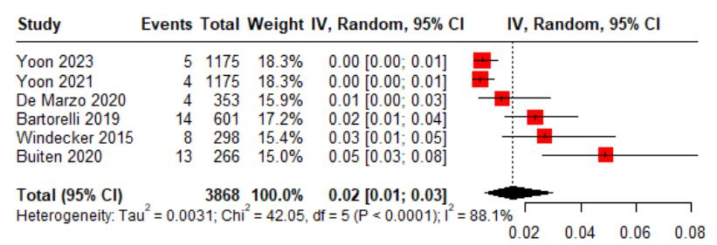
Figure S33. Forest plot of target vessel myocardial infarction in studies evaluating the Orsiro drug-eluting stent.
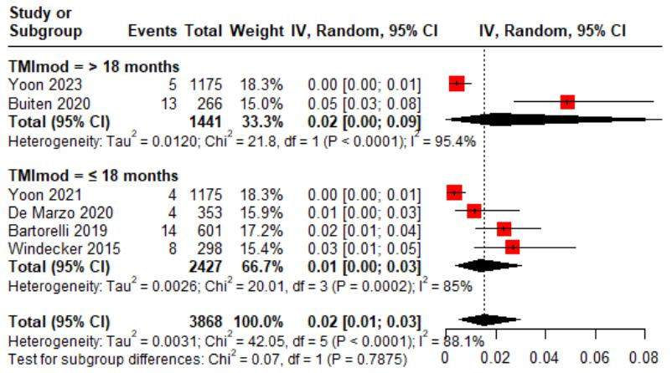
Figure S34. Subgroup analysis of target vessel myocardial infarction in studies evaluating the Orsiro drug-eluting stent.
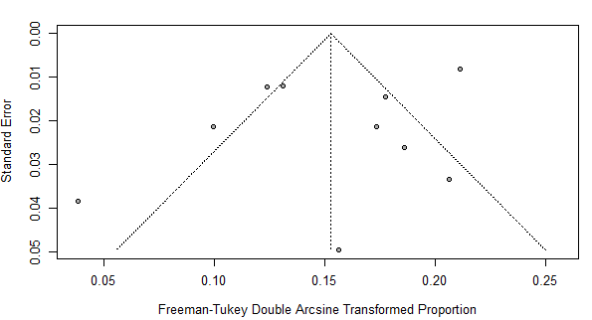

Figure S35. Funnel plot assessing publication bias for cardiac death in studies evaluating the Ultimaster drug-eluting stent.

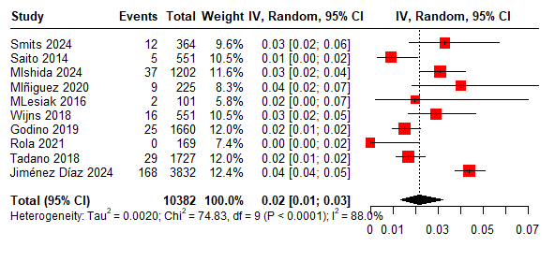
Figure S36. Forest plot of cardiac death in studies evaluating the Ultimaster drug-eluting stent.
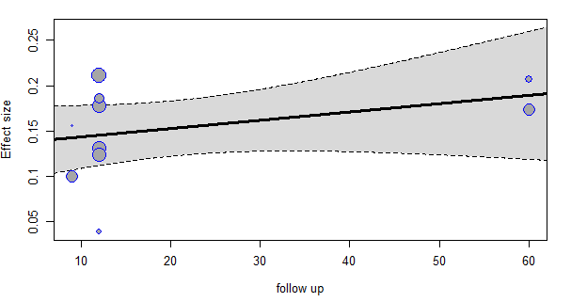
Figure S37. Regression analysis of cardiac death in studies evaluating the Ultimaster drug-eluting stent.

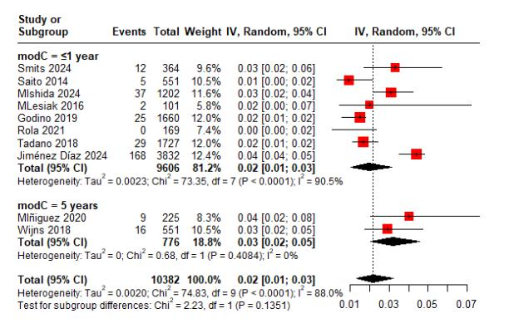
Figure S38. Subgroup analysis of cardiac death in studies evaluating the Ultimaster drug-eluting stent.

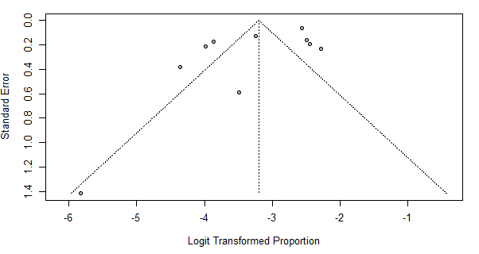
Figure S39. Funnel plot assessing publication bias for all-cause mortality in studies evaluating the Ultimaster drug-eluting stent.

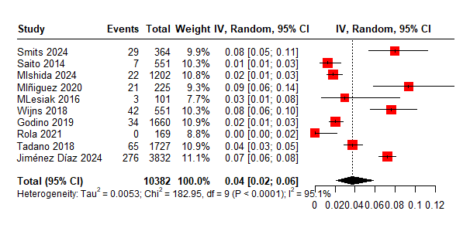
Figure S40. Forest plot of all-cause mortality in studies evaluating the Ultimaster drug-eluting stent.

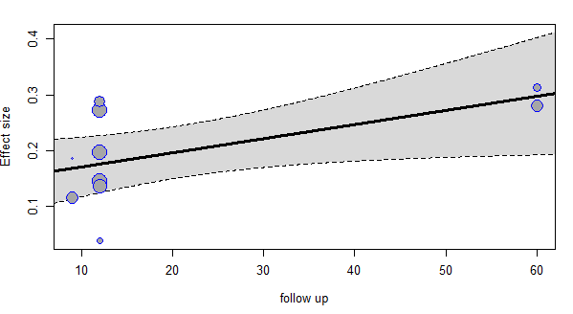
Figure S41. Regression analysis of all-cause mortality in studies evaluating the Ultimaster drug-eluting stent.

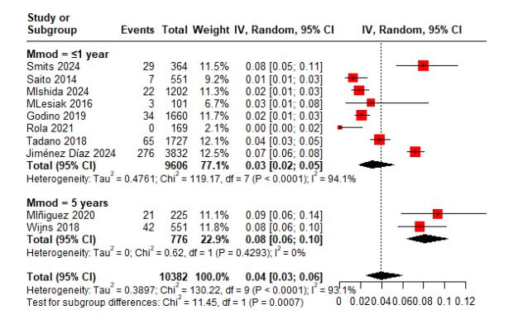
Figure S42. Subgroup analysis of all-cause mortality in studies evaluating the Ultimaster drug-eluting stent.

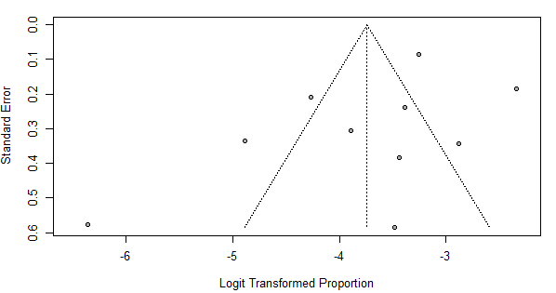
Figure S43. Funnel plot assessing publication bias for myocardial infarction in studies evaluating the Ultimaster drug-eluting stent.

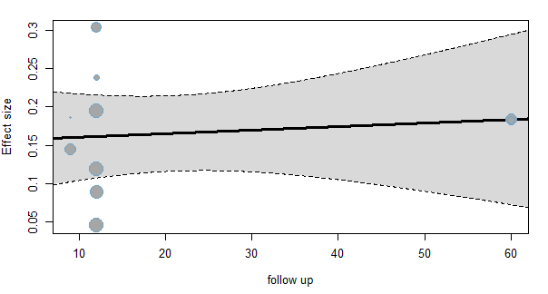
Figure S44. Regression analysis of myocardial infarction in studies evaluating the Ultimaster drug-eluting stent.
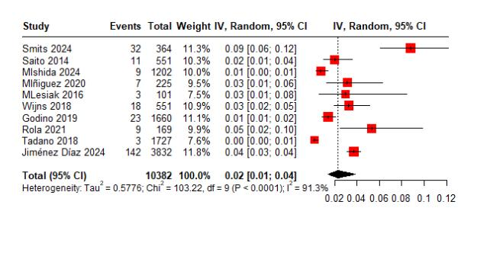
Figure S45. Forest plot of myocardial infarction in studies evaluating the Ultimaster drug-eluting stent.
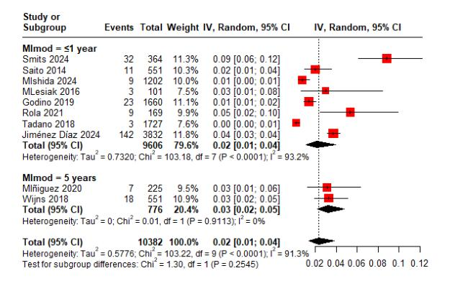

Figure S46. Subgroup analysis of myocardial infarction in studies evaluating the Ultimaster drug-eluting stent.
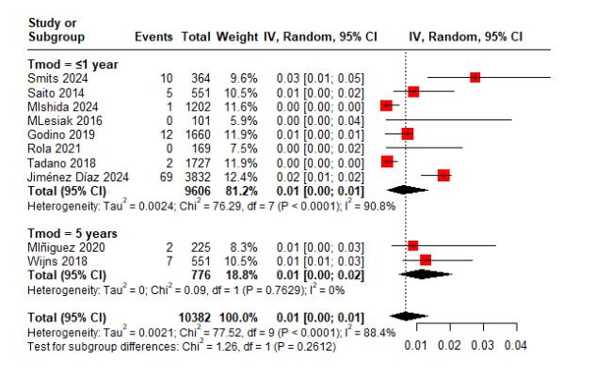
Figure S47. Subgroup analysis of stent thrombosis in studies evaluating the Ultimaster drug-eluting stent.

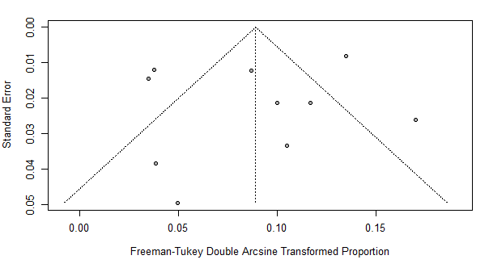
Figure S48. Funnel plot assessing publication bias for stent thrombosis in studies evaluating the Ultimaster drug-eluting stent.

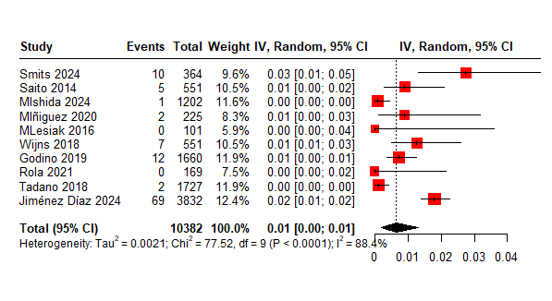
Figure S49. Forest plot of stent thrombosis in studies evaluating the Ultimaster drug-eluting stent.

 PRISMA 2020 Checklist
Section and Topic | Item # | Checklist item | Location where item is reported
TITLE
Title | 1 | Identify the report as a systematic review. | 1
ABSTRACT
Abstract | 2 | See the PRISMA 2020 for Abstracts checklist. | 2
INTRODUCTION
Rationale | 3 | Describe the rationale for the review in the context of existing knowledge. | 3
Objectives | 4 | Provide an explicit statement of the objective(s) or question(s) the review addresses. | 3
METHODS
Eligibility criteria | 5 | Specify the inclusion and exclusion criteria for the review and how studies were grouped for the syntheses. | 5
Information sources | 6 | Specify all databases, registers, websites, organisations, reference lists and other sources searched or consulted to identify studies. Specify the date when each source was last searched or consulted. | 5
Search strategy | 7 | Present the full search strategies for all databases, registers and websites, including any filters and limits used. | 5
Selection process | 8 | Specify the methods used to decide whether a study met the inclusion criteria of the review, including how many reviewers screened each record and each report retrieved, whether they worked independently, and if applicable, details of automation tools used in the process. | 7
Data collection process | 9 | Specify the methods used to collect data from reports, including how many reviewers collected data from each report, whether they worked independently, any processes for obtaining or confirming data from study investigators, and if applicable, details of automation tools used in the process. | 6
Data items | 10a | List and define all outcomes for which data were sought. Specify whether all results that were compatible with each outcome domain in each study were sought (e.g. for all measures, time points, analyses), and if not, the methods used to decide which results to collect. | 6
Data items | 10b | List and define all other variables for which data were sought (e.g. participant and intervention characteristics, funding sources). Describe any assumptions made about any missing or unclear information. | 6
Study risk of bias assessment | 11 | Specify the methods used to assess risk of bias in the included studies, including details of the tool(s) used, how many reviewers assessed each study and whether they worked independently, and if applicable, details of automation tools used in the process. | 6
Effect measures | 12 | Specify for each outcome the effect measure(s) (e.g. risk ratio, mean difference) used in the synthesis or presentation of results. | 7
Synthesis methods | 13a | Describe the processes used to decide which studies were eligible for each synthesis (e.g. tabulating the study intervention characteristics and comparing against the planned groups for each synthesis (item #5)). | 6
Synthesis methods | 13b | Describe any methods required to prepare the data for presentation or synthesis, such as handling of missing summary statistics, or data conversions. | 7
Synthesis methods | 13c | Describe any methods used to tabulate or visually display results of individual studies and syntheses. | 7-8
Synthesis methods | 13d | Describe any methods used to synthesize results and provide a rationale for the choice(s). If meta-analysis was performed, describe the model(s), method(s) to identify the presence and extent of statistical heterogeneity, and software package(s) used. | 7
Synthesis methods | 13e | Describe any methods used to explore possible causes of heterogeneity among study results (e.g. subgroup analysis, meta-regression). | 7
Synthesis methods | 13f | Describe any sensitivity analyses conducted to assess robustness of the synthesized results. | 7
Reporting bias assessment | 14 | Describe any methods used to assess risk of bias due to missing results in a synthesis (arising from reporting biases). | 13
Certainty | 15 | Describe any methods used to assess certainty (or confidence) in the body of evidence for an outcome. | 9
PRISMA 2020 Checklist
Section and Topic | Item # | Checklist item | Location where item is reported
assessment
RESULTS
Study selection | 16a | Describe the results of the search and selection process, from the number of records identified in the search to the number of studies included in the review, ideally using a flow diagram. | 7 Figure 1
Study selection | 16b | Cite studies that might appear to meet the inclusion criteria, but which were excluded, and explain why they were excluded. | 7 Figure 1
Study characteristics | 17 | Cite each included study and present its characteristics. | Table S2
Risk of bias in studies | 18 | Present assessments of risk of bias for each included study. | 8
Results of individual studies | 19 | For all outcomes, present, for each study: (a) summary statistics for each group (where appropriate) and (b) an effect estimate and its precision (e.g.  confidence/credible interval), ideally using structured tables or plots. | Table S2-S3
Results of syntheses | 20a | For each synthesis, briefly summarise the characteristics and risk of bias among contributing studies. | 11-12
Results of syntheses | 20b | Present results of all statistical syntheses conducted. If meta-analysis was done, present for each the summary estimate and its precision (e.g.  confidence/credible interval) and measures of statistical heterogeneity. If comparing groups, describe the direction of the effect. | 10
Results of syntheses | 20c | Present results of all investigations of possible causes of heterogeneity among study results. | 12
Results of syntheses | 20d | Present results of all sensitivity analyses conducted to assess the robustness of the synthesized results. | 12
Reporting biases | 21 | Present assessments of risk of bias due to missing results (arising from reporting biases) for each synthesis assessed. | 13
Certainty of evidence | 22 | Present assessments of certainty (or confidence) in the body of evidence for each outcome assessed. | 13
DISCUSSION
Discussion | 23a | Provide a general interpretation of the results in the context of other evidence. | 13
Discussion | 23b | Discuss any limitations of the evidence included in the review. | 17
Discussion | 23c | Discuss any limitations of the review processes used. | 17
Discussion | 23d | Discuss implications of the results for practice, policy, and future research. | 18
OTHER INFORMATION
Registration and protocol | 24a | Provide registration information for the review, including register name and registration number, or state that the review was not registered. | 4
Registration and protocol | 24b | Indicate where the review protocol can be accessed, or state that a protocol was not prepared. | 4
Registration and protocol | 24c | Describe and explain any amendments to information provided at registration or in the protocol. | 18
Support | 25 | Describe sources of financial or non-financial support for the review, and the role of the funders or sponsors in the review. | 18
Competing  interests | 26 | Declare any competing interests of review authors. | 18
Availability of data, code and other materials | 27 | Report which of the following are publicly available and where they can be found: template data collection forms; data extracted from included studies; data used for all analyses; analytic code; any other materials used in the review. | 19

Figure S50. Prisma checklist
From: Page MJ, McKenzie JE, Bossuyt PM, Boutron I, Hoffmann TC, Mulrow CD, et al. The PRISMA 2020 statement: an updated guideline for reporting systematic reviews. BMJ 2021;372:n71. doi: 10.1136/bmj.n71

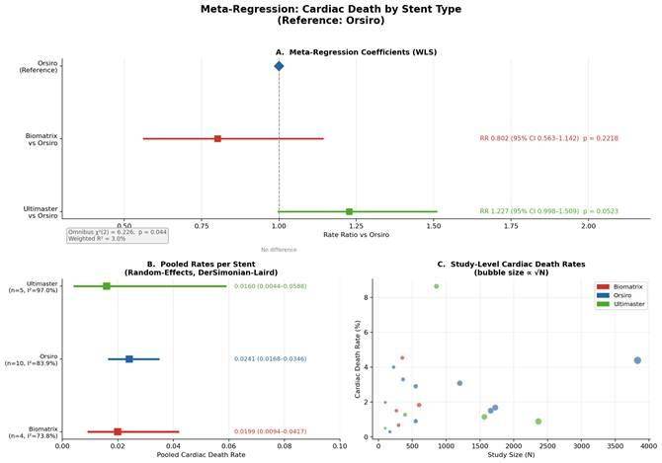

Figure S51. Meta-regression analysis of cardiac death by stent type (reference: Orsiro).
Panel A: Inverse-variance weighted least squares (WLS) meta-regression forest plot showing rate ratios (RR) and 95% confidence intervals (CI) for Biomatrix and Ultimaster relative to the Orsiro reference stent. The dashed vertical line indicates RR = 1.0 (no difference). Panel B: Pooled cardiac death rates per stent derived from DerSimonian-Laird random-effects models, with 95% CI and I² heterogeneity statistic. Panel C: Study-level cardiac death rates plotted against study size (N); bubble area is proportional to √N. Omnibus χ²(2) = 6.226, p = 0.044; weighted R² = 3.0%. Neither comparator reached statistical significance (Biomatrix: RR 0.802, p = 0.222; Ultimaster: RR 1.227, p = 0.052). High heterogeneity was present across all groups (I² = 74–97%). Abbreviations: CI, confidence interval; DL, DerSimonian-Laird; RR, rate ratio; WLS, weighted least squares.

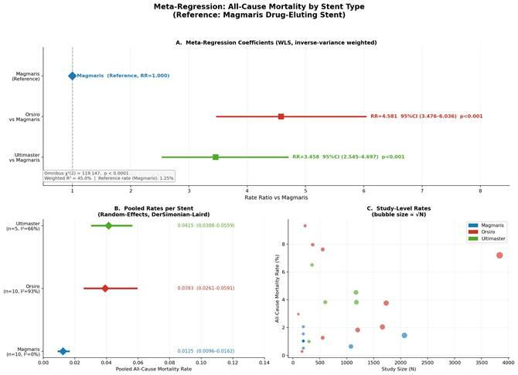

Figure S52. Meta-regression analysis of all-cause mortality by stent type (reference: Magmaris).
Panel A: WLS meta-regression forest plot showing RRs and 95% CIs for Orsiro and Ultimaster relative to Magmaris. Panel B: Pooled all-cause mortality rates per stent (random-effects, DL). Panel C: Study-level all-cause mortality rates by study size. Omnibus χ²(2) = 119.147, p < 0.0001; weighted R² = 45.0%. Both comparators were significantly higher than Magmaris: Orsiro RR 4.581 (95% CI 3.476–6.036, p < 0.001); Ultimaster RR 3.458 (95% CI 2.545–4.697, p < 0.001). The Magmaris pooled rate was 1.25% (I² = 0.0%), reflecting the homogeneous single-centre study programme; caution is warranted in direct comparisons with the multicentre Orsiro (I² = 93%) and Ultimaster (I² = 66%) cohorts. Abbreviations: CI, confidence interval; DL, DerSimonian-Laird; RR, rate ratio; WLS, weighted least squares.

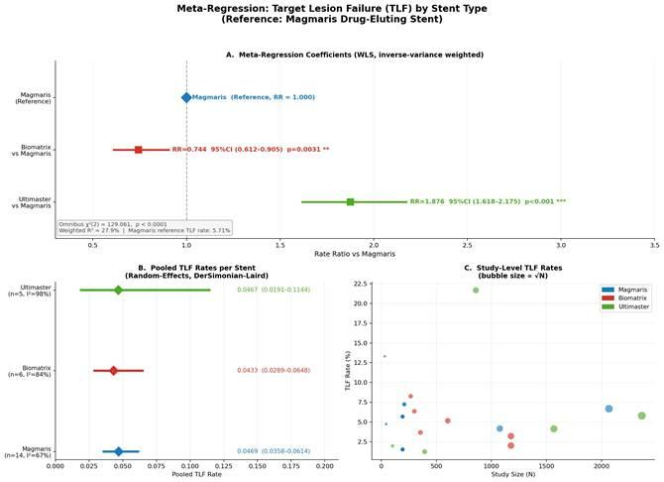

Figure S53. Meta-regression analysis of target lesion failure (TLF) by stent type (reference: Magmaris).
TLF is a composite of cardiac death, target vessel myocardial infarction, and target lesion revascularization. Panel A: WLS meta-regression forest plot showing RRs and 95% CIs for Biomatrix and Ultimaster relative to Magmaris. Panel B: Pooled TLF rates per stent (random-effects, DL). Panel C: Study-level TLF rates by study size. Omnibus χ²(2) = 129.061, p < 0.0001; weighted R² = 27.9%. Biomatrix demonstrated a significantly lower TLF rate (RR 0.744, 95% CI 0.612–0.905, p = 0.003); Ultimaster a significantly higher rate (RR 1.876, 95% CI 1.618–2.175, p < 0.001). The Ultimaster estimate is heavily influenced by the Lee 2019 outlier study (TLF rate 21.7%), which drives extreme heterogeneity (I² = 98.5%). Abbreviations: CI, confidence interval; DL, DerSimonian-Laird; RR, rate ratio; TLF, target lesion failure; WLS, weighted least squares.

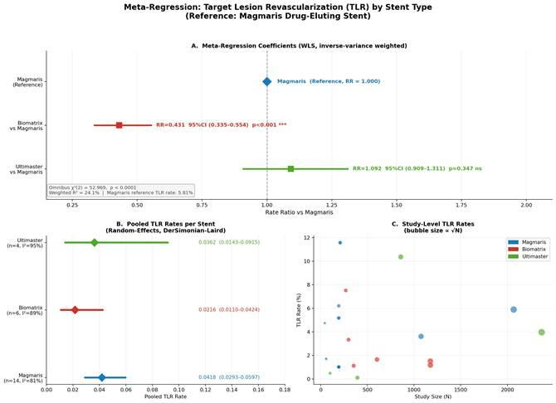

Figure S54. Meta-regression analysis of target lesion revascularization (TLR) by stent type (reference: Magmaris).
Panel A: WLS meta-regression forest plot showing RRs and 95% CIs for Biomatrix and Ultimaster relative to Magmaris. Panel B: Pooled TLR rates per stent (random-effects, DL). Panel C: Study-level TLR rates by study size. Omnibus χ²(2) = 52.969, p < 0.0001; weighted R² = 24.1%. Biomatrix demonstrated the largest and most significant between-stent difference across all endpoints (RR 0.431, 95% CI 0.335–0.554, p < 0.001), representing a ~57% reduction in TLR relative to Magmaris. Ultimaster was not significantly different from Magmaris (RR 1.092, 95% CI 0.909–1.311, p = 0.347). Two zero-event studies in the Ultimaster group (Seth 2013, Separham 2011) received continuity corrections of +0.5 events. Abbreviations: CI, confidence interval; DL, DerSimonian-Laird; RR, rate ratio; TLR, target lesion revascularization; WLS, weighted least squares.

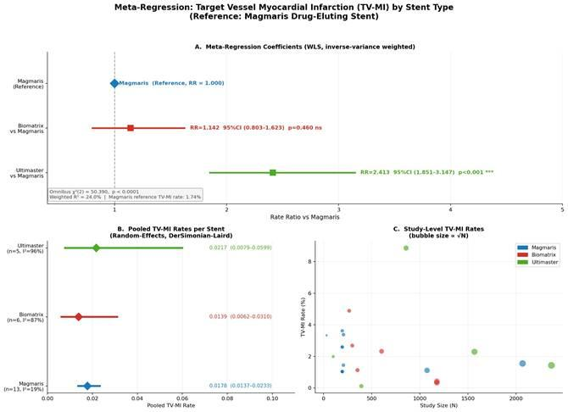
Figure S55. Meta-regression analysis of target vessel myocardial infarction (TV-MI) by stent type (reference: Magmaris).
Panel A: WLS meta-regression forest plot showing RRs and 95% CIs for Biomatrix and Ultimaster relative to Magmaris. Panel B: Pooled TV-MI rates per stent (random-effects, DL). Panel C: Study-level TV-MI rates by study size. Omnibus χ²(2) = 50.390, p < 0.0001; weighted R² = 24.0%. Ultimaster was associated with a significantly higher TV-MI rate (RR 2.413, 95% CI 1.851–3.147, p < 0.001), substantially influenced by the Lee 2019 outlier (TV-MI rate 8.87%; Ultimaster I² = 96.3%). Biomatrix was not significantly different from Magmaris (RR 1.142, 95% CI 0.803–1.623, p = 0.460). Magmaris demonstrated the lowest between-study heterogeneity of any stent group across all five outcomes (I² = 19.1%, tau² = 0.042). One zero-event study (Seth 2013) received a continuity correction of +0.5 events. Abbreviations: CI, confidence interval; DL, DerSimonian-Laird; RR, rate ratio; TV-MI, target vessel myocardial infarction; WLS, weighted least squares.

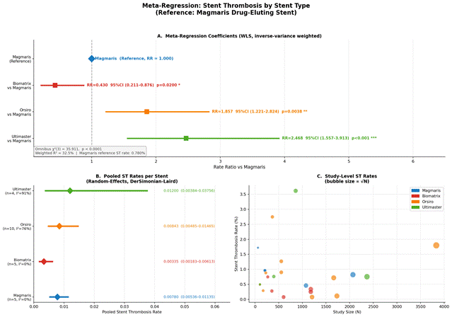

Figure S56. Meta-regression analysis of stent thrombosis by stent type (reference: Magmaris).

Figure. A) Meta-regression coefficients (WLS) with Magmaris as reference — Biomatrix significantly lower ST (RR=0.430, p=0.020); Orsiro significantly higher (RR=1.857, p=0.004); Ultimaster significantly higher (RR=2.468, p<0.001). B) Pooled ST rates by stent (random-effects DL). C) Study-level ST rates, bubble size proportional to √N.

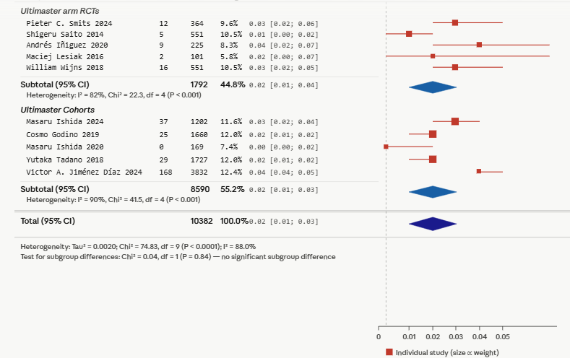
Figure S57. Forest plot of cardiac death in studies evaluating the Ultimaster drug-eluting stent, stratified by study type.

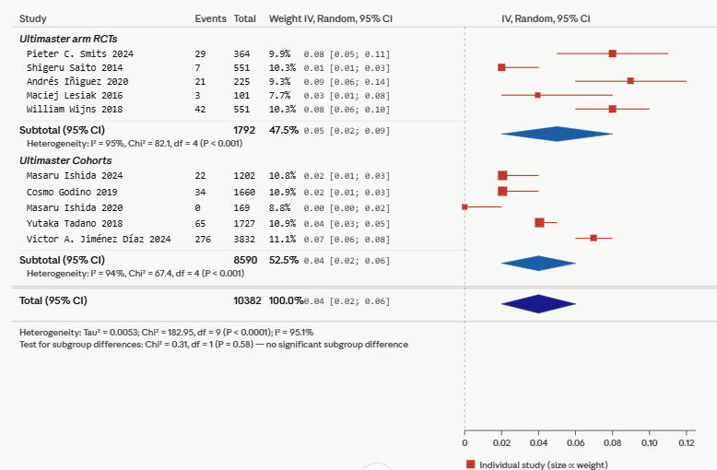

Figure S58. Forest plot of all-cause mortality in studies evaluating the Ultimaster drug-eluting stent, stratified by study type.

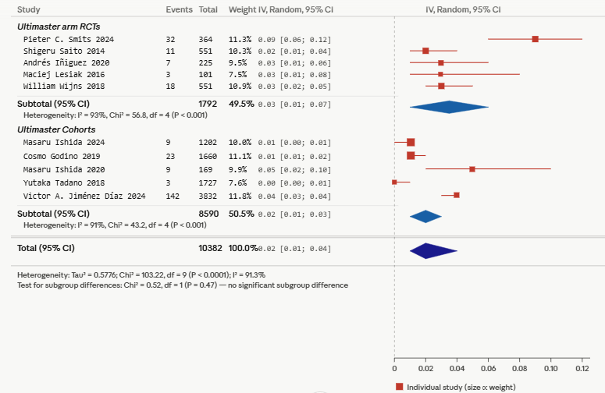
Figure S59. Forest plot of myocardial infarction in studies evaluating the Ultimaster drug-eluting stent, stratified by study type.

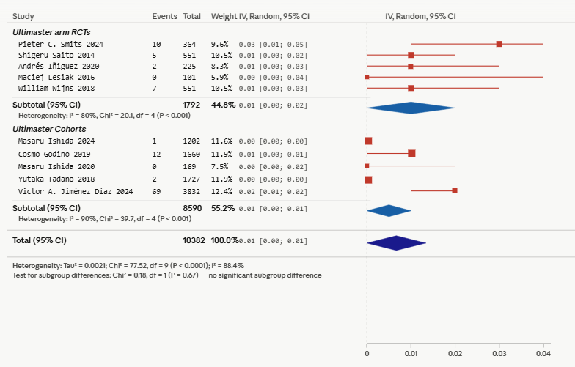
Figure S60. Forest plot of stent thrombosis in studies evaluating the Ultimaster drug-eluting stent, stratified by study type.

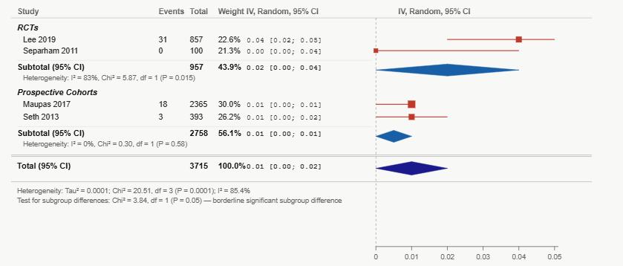
Figure S61. Forest plot of stent thrombosis in studies evaluating Biomatrix stents, stratified by study type.

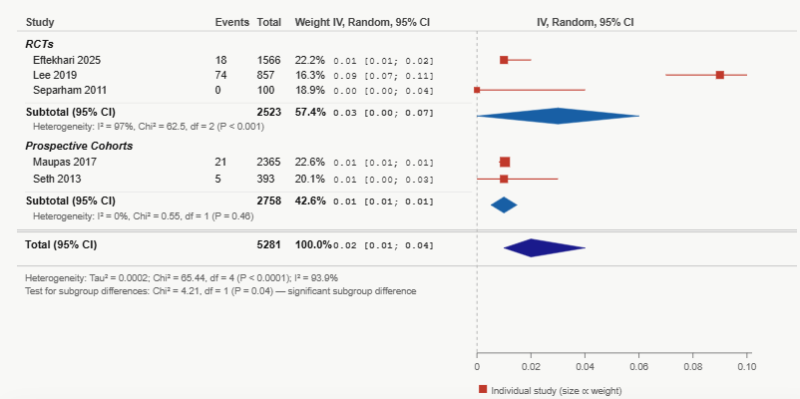
Figure S62. Forest plot of cardiac death in studies evaluating Biomatrix stents, stratified by study type.

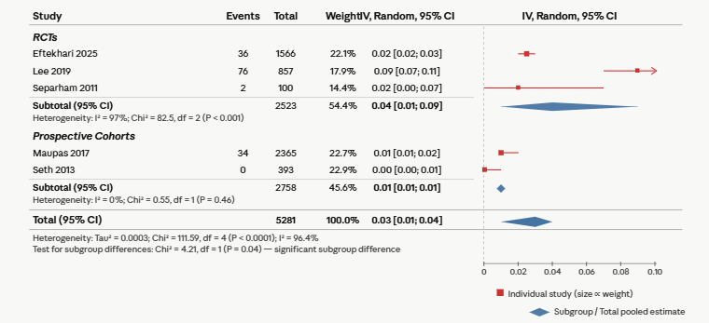

Figure S63. Forest plot of target vessel myocardial infarction in studies evaluating the Biomatrix drug-eluting stent, stratified by study type.

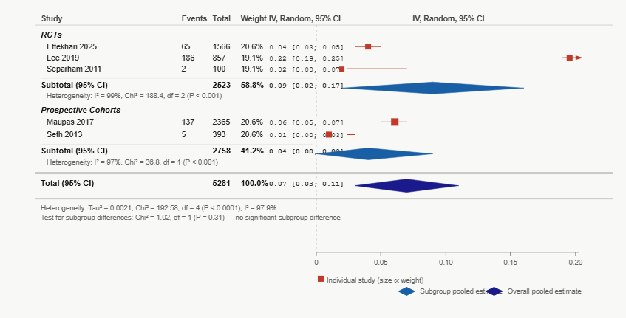
Figure S64. Forest plot of target lesion failure in studies evaluating the Biomatrix drug-eluting, stratified by study design

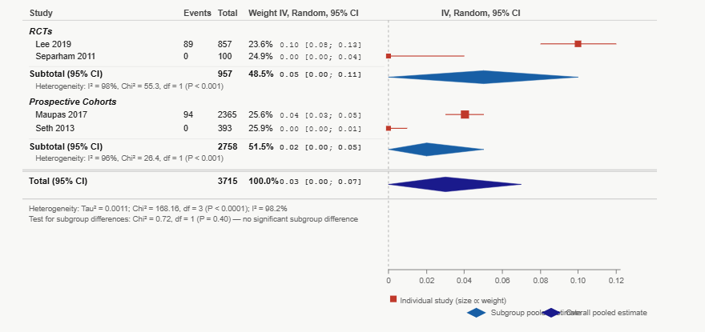

Figure S65. Forest plot of target lesion revascularization in studies evaluating the Biomatrix drug-eluting stent, stratified by study design

