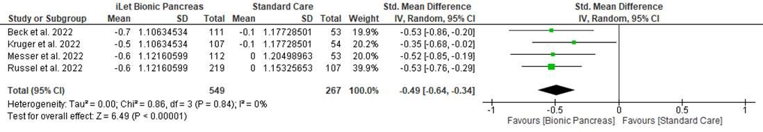
Figure S1. Comparison of HbA1c levels between iLet group and Standard care group.
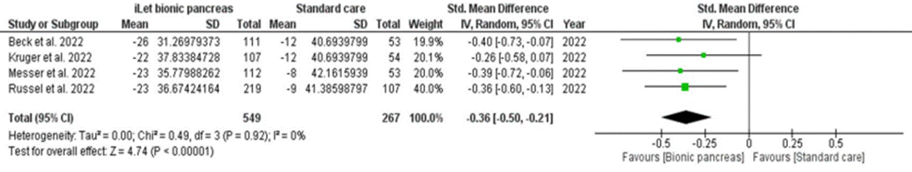
Figure S2. Comparison of reduction in Mean glucose levels between iLet group and Standard care group.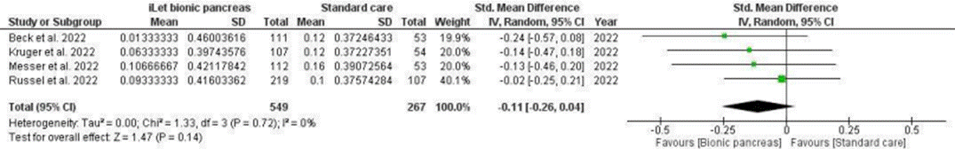
Figure S3. Change in percentage time the glucose level was <54mg/dl between iLet group and Standard care group 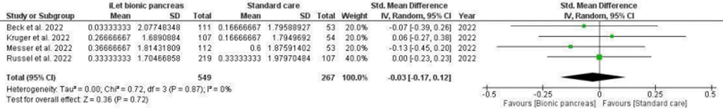
Figure S4. Change in percentage time the glucose level was <70mg/dl between iLet group and Standard care group.
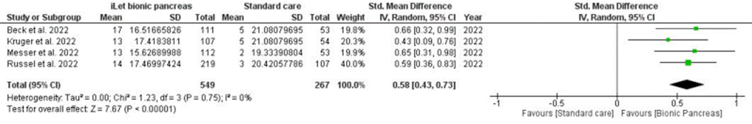Figure S5. Change in percentage time the glucose level was 70-180mg/dl between iLet group and Standard Care group
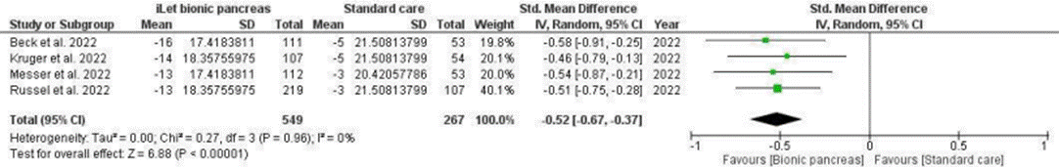Figure S6. Change in percentage time the glucose level was >180mg/dl between iLet group and Standard Care group
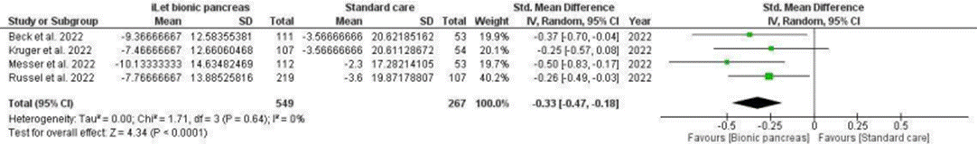Figure S7. Change in percentage time the glucose level was >250mg/dl between iLet group and Standard care group
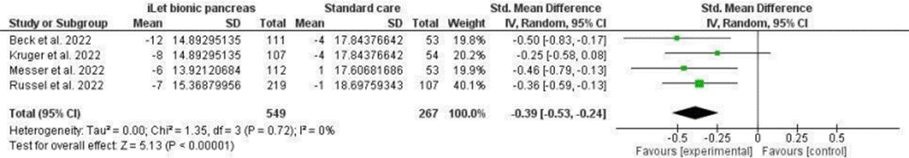Figure S8. Comparison of Glucose standard deviation between iLet group and Standard care group.
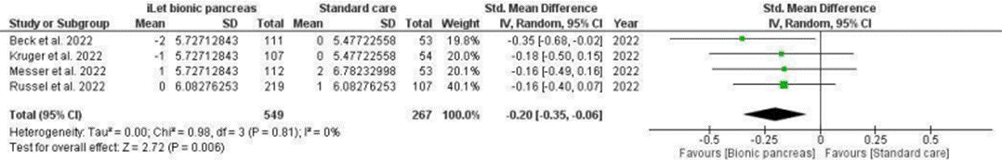Figure S9. Comparison of Coefficient of variation between iLet group and Standard care group.
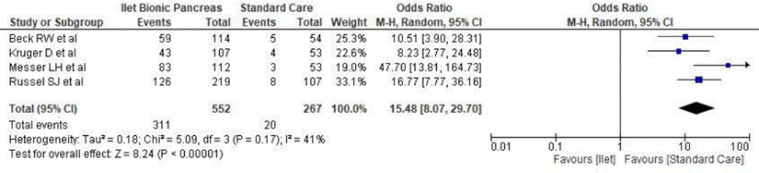Figure S10. Demonstrating Any adverse event in iLet group and Standard care group
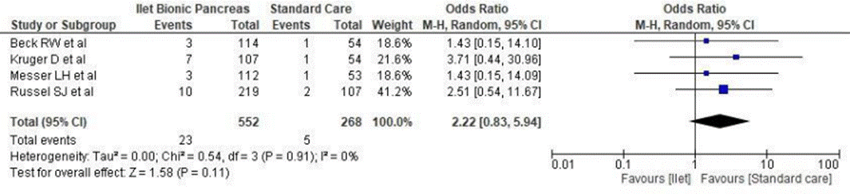Figure S11. Comparison of Severe Hypoglycemia seen in iLet group and Standard care group.
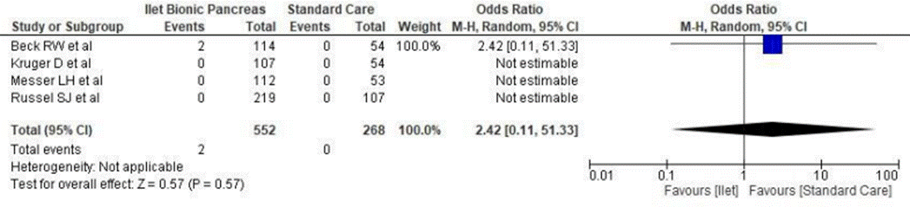Figure S12. Comparison of Diabetic ketoacidosis seen in iLet group and Standard care group
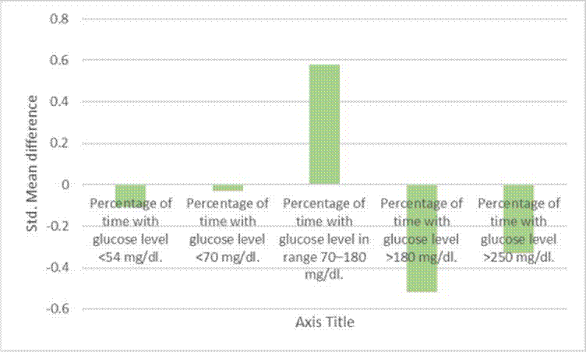
Figure S13. Bar chart showing the SMD for iLet BP and SC for change in time duration the patients had their glucose levels in the mentioned range.
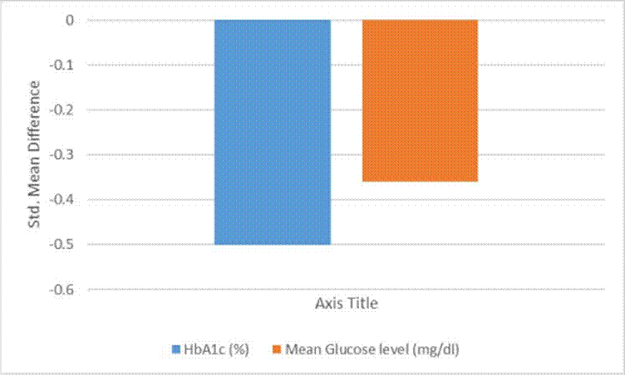Figure S14. Bar chart showing the SMD for iLet BP and SC for change in HbA1c and Mean glucose levels.
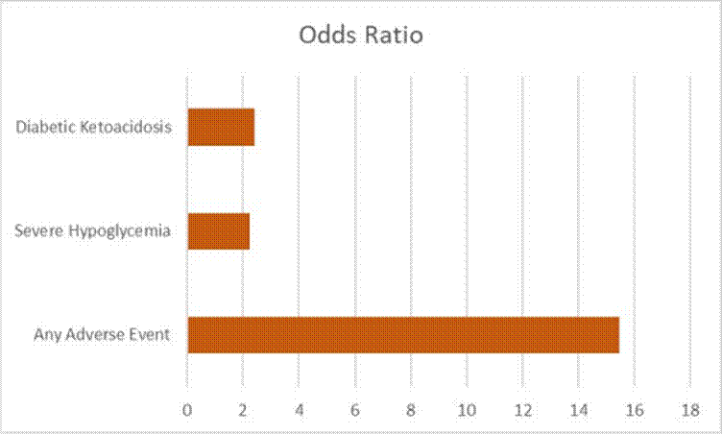
Figure S15. Bar chart showing the Odds Ratios iLet BP and SC for adverse events experienced by the patients after each intervention.

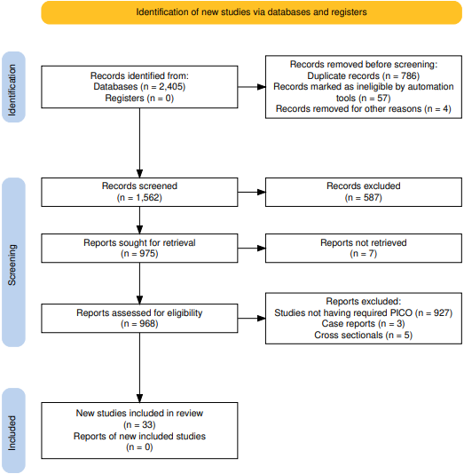

Figure S16. Prisma Flow Chart
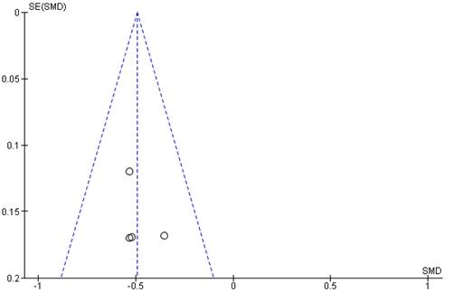
Figure S17. Funnel plot to assess publication bias in mean HbA1c outcome.
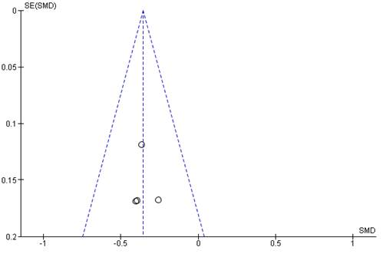
Figure S18. Funnel plot to assess publication bias in Mean glucose level outcome.

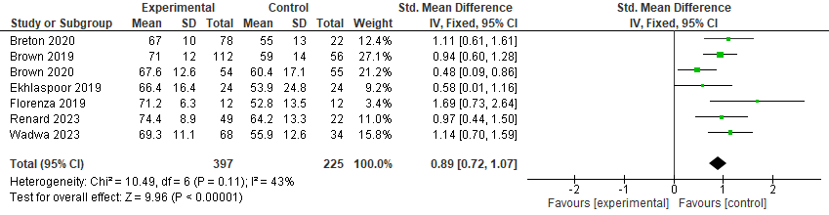
Figure S19.Change in percentage time the glucose level was 70-180mg/dl between Control IQ group and Standard care group
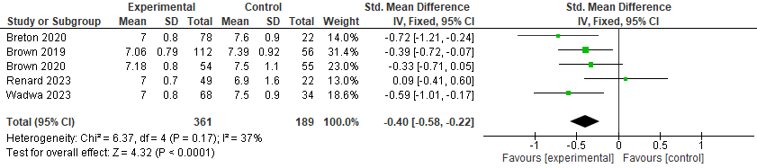

Figure S20.Hba1c level between control IQ and standard care group.

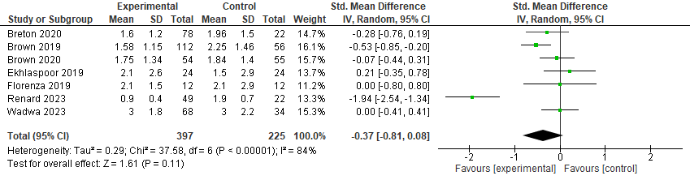
Figure S21. Change in percentage time the glucose level was <70mg/dl between Control IQ group and Standard care group

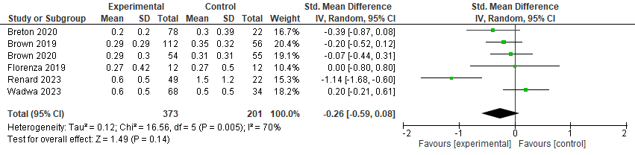
Figure S22.Change in percentage time the glucose level was <54mg/dl between Control IQ group and Standard care group

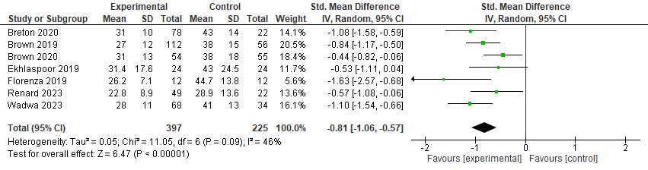
Figure S23.Change in percentage time the glucose level was >180mg/dl between Control IQ group and Standard care group

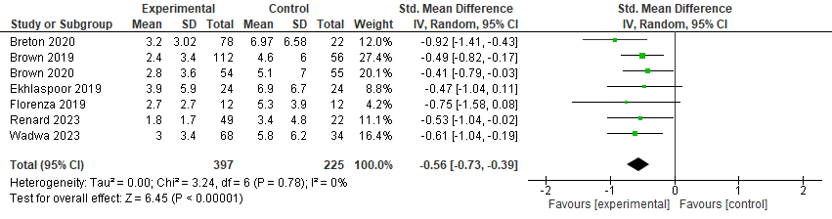
Figure S24.Change in percentage time the glucose level was >250mg/dl between Control IQ group and Standard care group

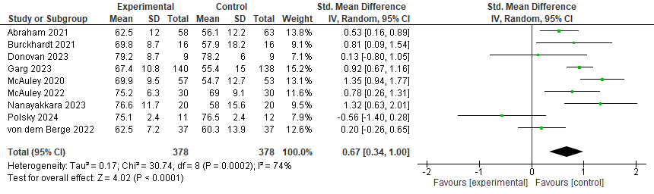

Figure S25.Forest plot showing the pooled effect of the Medtronic MiniMed™ 670G hybrid closed-loop system compared with a control group on time in range (70–180 mg/dL), expressed as mean difference with 95% confidence intervals.

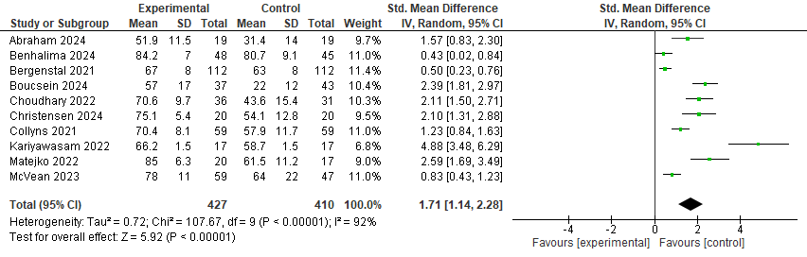
Figure S26.Forest plot showing the pooled effect of the Medtronic MiniMed™ 780G advanced hybrid closed-loop system compared with a control group on time in range (70–180 mg/dL), expressed as mean difference with 95% confidence intervals.

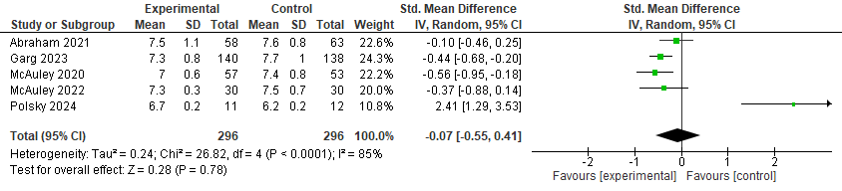
Figure S27.Forest plot demonstrating the pooled effect of the Medtronic MiniMed™ 670G system compared with a control group on HbA1c (%), reported as mean difference with 95% confidence intervals.

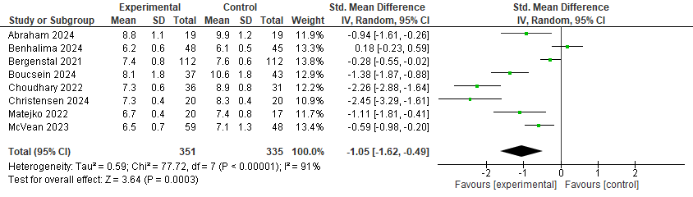
Figure S28.Forest plot demonstrating the pooled effect of the Medtronic MiniMed™ 780G system compared with a control group on HbA1c (%), reported as mean difference with 95% confidence intervals.

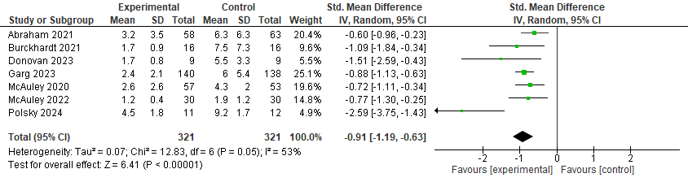
Figure S29.Forest plot illustrating the pooled effect of the Medtronic MiniMed™ 670G system compared with a control group on time below range (TBR <70 mg/dL), expressed as mean difference with 95% confidence intervals.

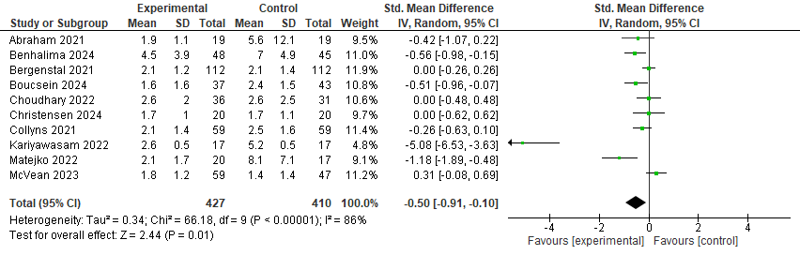
Figure S30.Forest plot illustrating the pooled effect of the Medtronic MiniMed™ 780G system compared with a control group on time below range (TBR <70 mg/dL), expressed as mean difference with 95% confidence intervals.

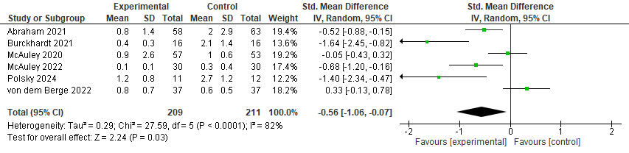
Figure S31.Forest plot showing the pooled effect of the Medtronic MiniMed™ 670G system compared with a control group on clinically significant hypoglycemia (TBR <54 mg/dL), expressed as mean difference with 95% confidence intervals.

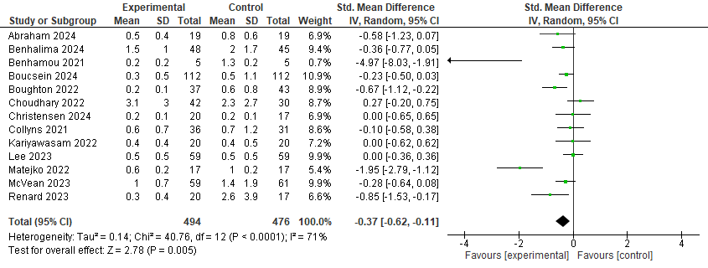
Figure S32.Forest plot showing the pooled effect of the Medtronic MiniMed™ 780G system compared with a control group on clinically significant hypoglycemia (TBR <54 mg/dL), expressed as mean difference with 95% confidence intervals.

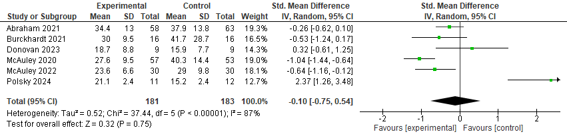
Figure S33.Forest plot depicting the pooled effect of the Medtronic MiniMed™ 670G system compared with a control group on time above range (TAR >180 mg/dL), expressed as mean difference with 95% confidence intervals.

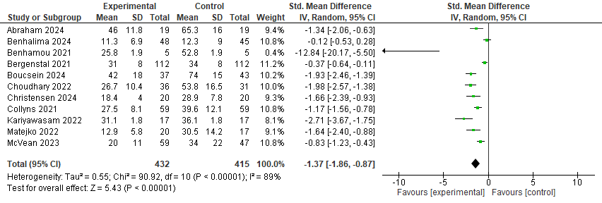Figure S34.Forest plot depicting the pooled effect of the Medtronic MiniMed™ 780G system compared with a control group on time above range (TAR >180 mg/dL), expressed as mean difference with 95% confidence intervals.

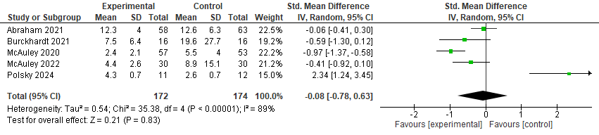
Figure S35.Forest plot showing the pooled effect of the Medtronic MiniMed™ 670G system compared with a control group on severe hyperglycemia (TAR >250 mg/dL), expressed as mean difference with 95% confidence intervals.

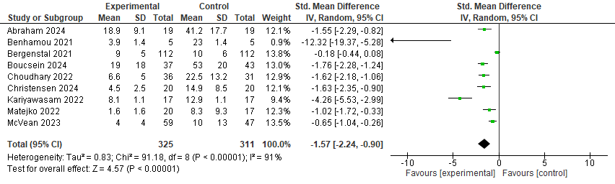

Figure S36.Forest plot showing the pooled effect of the Medtronic MiniMed™ 780G system compared with a control group on severe hyperglycemia (TAR >250 mg/dL), expressed as mean difference with 95% confidence intervals.

