**Supplementary Figure 1**

a b

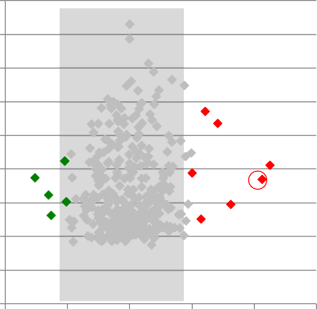18

16

14

12

A (Intensity)

A (Intensity)

10

8

6

4

2

0

-2 -1 0 1 2 3

18

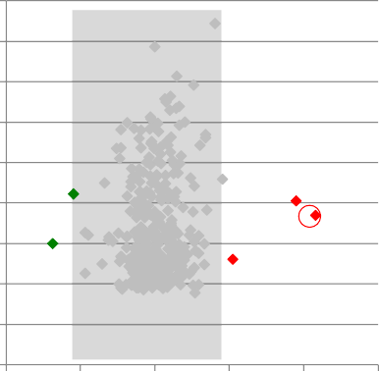16

14

12

10

8

6

4

2

0

-2 -1 0 1 2 3

M (Log2 Fold change) M (Log2 Fold change)

**Supplementary figure 1:** Alteration of miRNA levels upon the selection of chemoresistant cells from CSC-enriched populations. MA plot resulting from miRNA microarray data that were quantile normalized based on summarized expression levels of probe sets. The M value represents the log2 fold change for a given miRNA probe set, when comparing treated to untreated cells. The A value of a probe set is the mean of all expression levels, expressed as the log2 of the raw values of all assay conditions. **(a)** MA plot comparing MCF7 mammospheres versus MCF7 mammospheres resistant to 5-FU. **(b)** MA plot comparing MCF7 mammospheres versus MCF7 mammospheres resistant to paclitaxel. miRNA expressed at lower levels in the resistant population are shown in green, whereas more highly expressed miRNA are shown in red. The circled diamonds depict miR-363- 3p.

**Supplementary Figure 2**

900

800

700

600

**Fold change**

500

400

300

200

100

0

MCF10A MCF7 MDA-MB-231 BT549 HCC 70 HCC 38

**Supplementary figure 2:** miR-363-3p expression is a marker of breast cancer cells. miR-363-3p level were assessed by RT-qPCR in different breast cancer cell lines and in normal-like MCF10A breast cells grown in adherent conditions.

**Supplementary Figure 3**

16

14

12

Relative miR-363-3p level

10

8

6

4

2

0

0 3 6 9 12 15 18 21 24 27 30 33 36 39 42 45

Time after induction (h)

**Supplementary figure 3:** miR-363-3p expression time course after miR-363-3p transfection in MCF7 cells. The relative levels of miR-363-3p were determined at the indicated times after induction of the miR-363-3p expression by doxycycline addition.

**Supplementary Figure 4**

Anti-miR-363-3p

miR-363-3p

miR-control

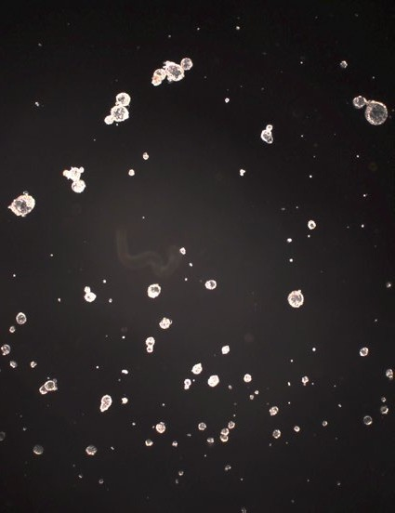 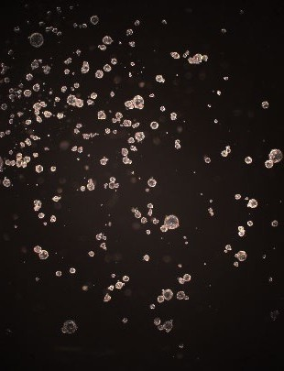 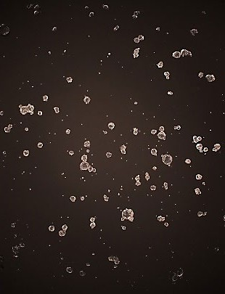

Relative

sphere 27

number

69 57

**Supplementary figure 4**: The effect of miRNA-363-3p inhibition on mammosphere size and number was determined by fluorescence microscopy. The number of spheres were determined from miR-control, miRNA-363-3p and anti-miRNA-363-3 expressing MCF7 cells, to show similar sphere numbers when comparing miR-control and miR-363-3p expressing MCF7 cells.

**Supplementary Table 1**

**Supplementary Table 1.** Summary of the sequences of oligonucleotides used for the construction of miRNA expression vectors.

